**SPRINT DELIVERY 3**

# REQUIREMENT ANALYSIS

* **CUSTOMER JOURNEY**
* **DATA FLOW DIAGRAMS**
* **TECHNOLOGY ARCHITECTURE**

TEAM ID :PNT2022TMID31031

**Smart Waste Management System for Metropolitan Cities**

## Objectives :

**Functional Requirements**

The main objective of the smart waste management system is to develop a new type of waste management in government and indvidial waste treatement industries to gather waste material for the purpose of recyling and desposol of human waste products

,elctronics,medical to be disposed safely with usage of multiple modern developed web based user mangement and IOT devices based on the garbage bin

## End result :

The garbage bin consist of IOT devices at the top and bottom of the garbage bin which helps to analyze the wieght and the amount of space in the dusbin which helps the worker and the waste management to accquire date of waste products dropped by people at individual loaction inoder to maintain an collect and cover an vast area of the city with the report givin by the garbage bins .

## Focus :

The customer or the person who proceds to drop and waste in the dustbin must notify the type of waste was to dropped , The method will helps prevention of liquid matter which to dropped which may cause damage to the IOT Devices in bottom , SInce the specification known only to the Smart city management team , they must advice the worker to conduct an journey to analyze how people dropp their waste based on their activites which help the worker to advice the customer to aware of the device inside the dustbin.

## Essentiality :

The IOT device must send data to the Smart city waste management team inorder to check the level of the dustin space and the area location where it currently moves , it must send indication level time to time for filling of the waste products ,the localized dustbin may vary from small dustbin to bigger truck as the IOT devices may eligible for both of them

Customer Journey Map

|  |  |  |  |  |
| --- | --- | --- | --- | --- |
| **Awarness** | | **Interact** | **Engage** | **Submit** |
| **Objectives** | How much wastage you  have ? | Identify the wastage ask to  drop i t | Maintaining the level and  area of location | Statistics obtained to  wastage department |
| **Needs** | Household bin to drop | Sharing of bin to  department | Kind  intraction with the worker | Satisfaction |
| **Barriers** | Weightage | Must provide the type of  wastage dropping | Maintain distance while  dropping | Convinced |

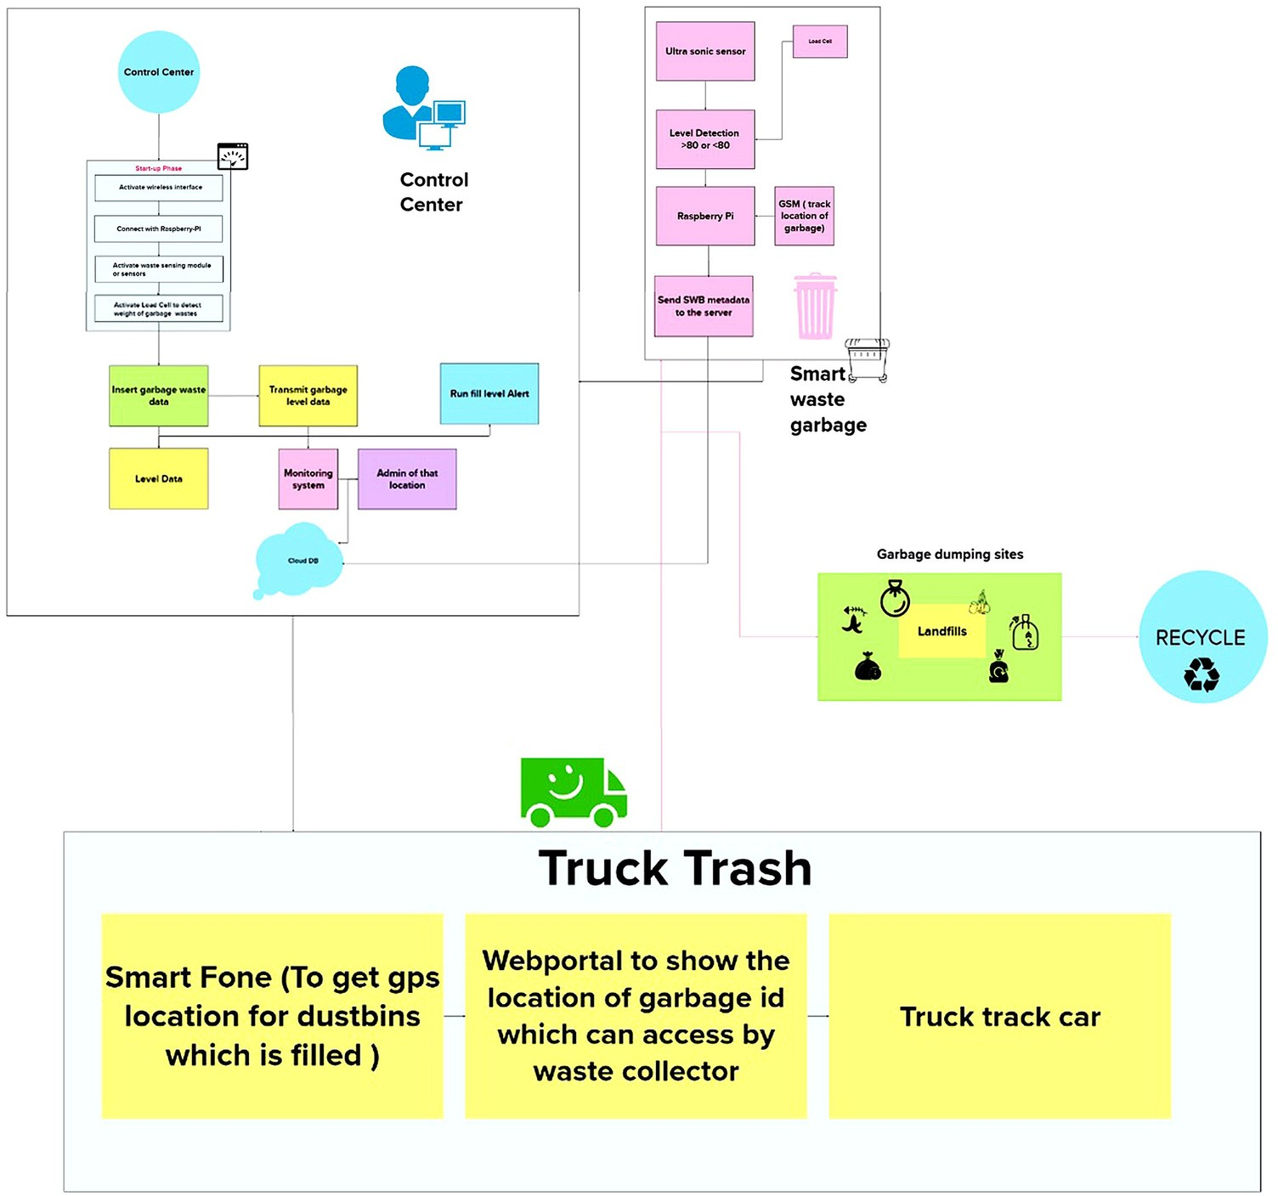

**TECHNOLOGY ARCHITECTURE**